**MUHAMMAD Hussnain Sheikh**

**FA22-BCS-011**

**BCS-C**

**Wholesale Inventory Management System (bicycle parts)**

We have to make a wholesale inventory management system that includes purchases, orders, inventory, and customer records. The company purchases many types of different products from many suppliers and sells them to many customers according to the orders. There are many types of each product, and each type of product has its price according to its size. Many types have many sizes. If the customers want to purchase a product of a specific type of a specific size, they order the product of that type in a specific size. One customer orders many orders, and many orders contain many types of products. Employees sell the products, many employees sell many products according to the type and sizes.

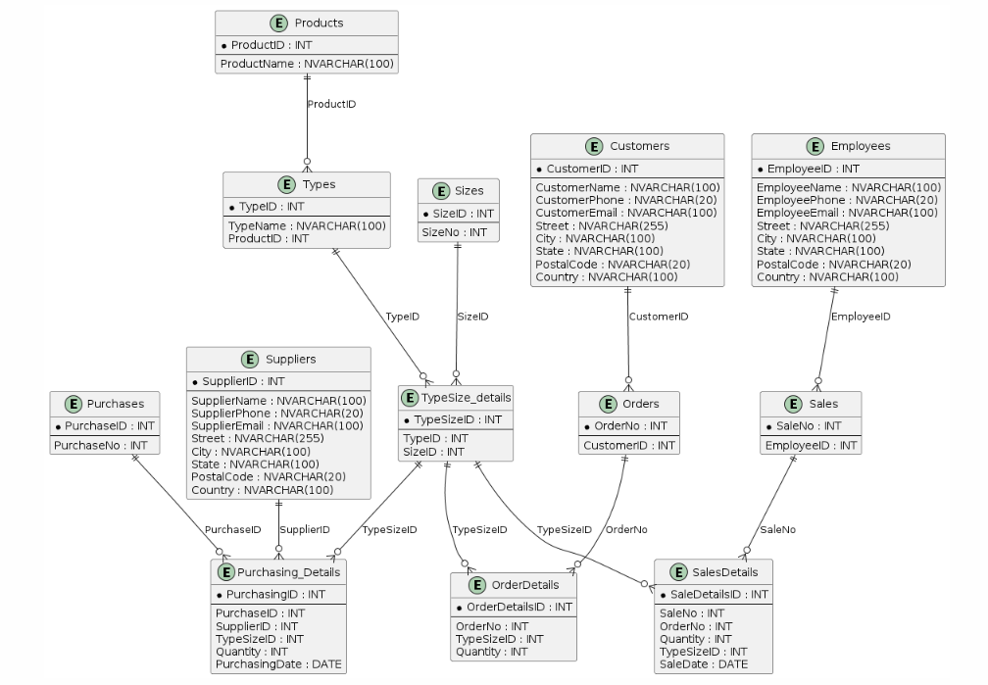

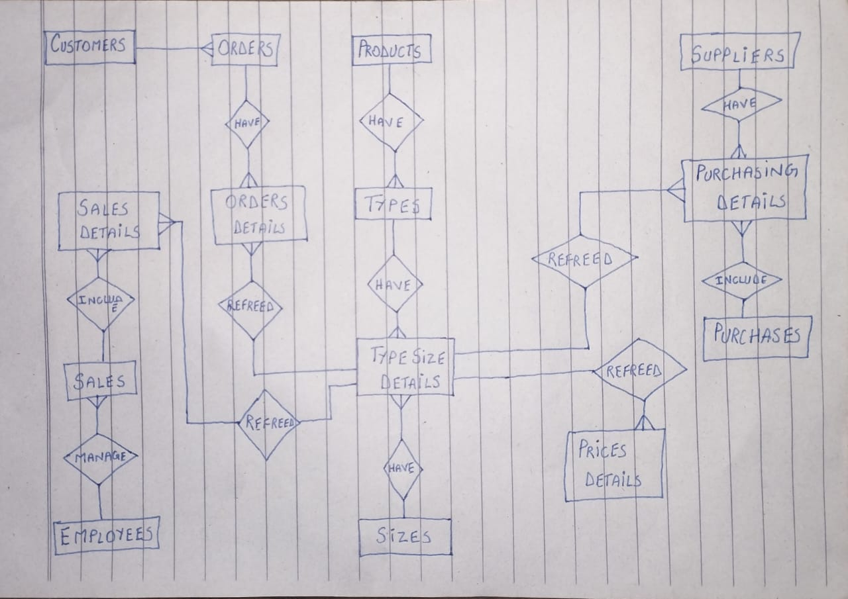

**Transactional Entities:**

* Purchasing details
* Prices details
* Orders details
* Sales details
* Type size details

**Components Entities:**

* Customers
* Suppliers
* Employees
* Products

**Classificational Entities:**

* Sales
* Purchases
* Orders
* Types
* Sizes